CLASS X
MATHEMATICS
Introduction to Trigonometry
Handout (Module 2 of 3)
Value of trigonometric-ratios of some specific angles:
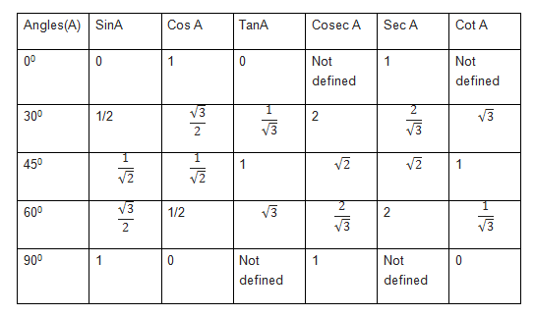
The value of sin θ and cos θ can never exceed 1 (one) as opposite side and the adjacent side can never be greater than the hypotenuse since the hypotenuse is the longest side in a right-angled triangle.
The value of Sec θ or Cosec θ is always greater than or equal to 1.

